
Brintons launches new commercial carpet collection, Studio Play

New collection delivers artistic flooring design for the hospitality, retail, and corporate sectors

Heritage carpet manufacturer Brintons has launched Studio Play, a new commercial carpet collection engineered for the demands of high-traffic contract environments. Developed through a series of in-house creative workshops, the collection brings an expressive, artisan aesthetic to a specification-grade product built for hospitality, retail, and corporate interiors.

Jodie Hatton, Design Manager at Brintons, notes, “We have an incredibly experienced design team, and with that experience comes deep knowledge of our craft. Studio Play gives us the opportunity to pause, experiment and work without pressure. It’s been rewarding to see the team embrace that freedom and turn it into a collection that feels both expressive and relevant.”

Series One: Acrylic Ink Exploration

For Series One, the team was invited to play with fluid acrylic inks. The session was intentionally led without a brief, in order to create an open environment where the team was able to experiment, layer and respond instinctively without pressure or intimidation. The result was a body of expressive, unexpected work rich in depth, gesture and atmosphere.

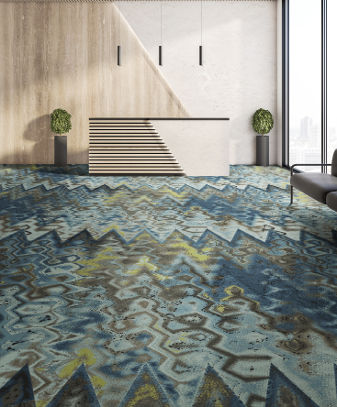 | 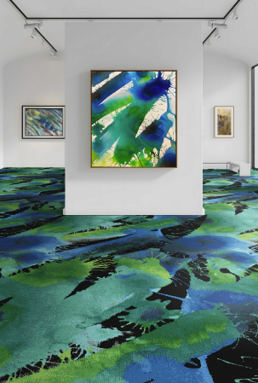
Studio Play, Series One carpet collection by Brintons, www.brintons.net

 |  |  |  | 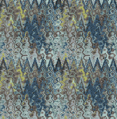
 |  | 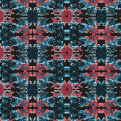 |  | 

Series Two: Gelli Printing

Studio Play will continue with Gelli printing; a process that embraces texture, layering, and surprise. As the series evolves, each workshop will build on the same philosophy as Series One: create first, design later.

Commercial carpets manufactured for unparalleled performance

Engineered from a durable 80% wool and 20% nylon yarn blend, Studio Play combines bold expression with commercial-grade performance. This premium composition ensures exceptional durability, stain resistance, and longevity, essential qualities for high-traffic hospitality and commercial environments, while maintaining the natural beauty and comfort of wool.

Characterised by layered patterns, rich textures and a fusion of heritage and contemporary designs, Studio Play offers an elevated, artistic appeal for a range of commercial interiors, where creating an atmosphere of comfort and sophistication is paramount.

Series One of the Studio Play collection is available now through Brintons' global network of dealers and design professionals. For more information, visit www.brintons.net

Notes to editors:
Brintons Carpets is a market-leading supplier of woven carpets to the worldwide hospitality, marine, gaming, leisure, private and public sectors. Committed to the concept of thinking globally and acting locally, Brintons has design studios, offices and agents in all of the major markets around the world.
Brintons Carpets product portfolio includes premium woven Axminster and Wilton broadloom carpets, carpet tiles, machine-made rugs and hand-tufted rugs. The company operates wholly owned ISO 14001 accredited facilities. Manufacturing is located in Portugal, Poland and India.
www.brintons.net

3-4a Little Portland Street
London W1W 7JB
W - www.purepr.com T - @pureprlondon I - @pureprlondon
For press enquiries please contact rebecca@purer.com, cecily@purepr.com and mansi@purepr.com | ph. 020 7580 0444

